**Analysis of Industry specific Rank/Score to Injury levels Insurance Premium**

Minimum wage data is sources from DOL website and injury data sourced from www.osha.gov. To analyze the dataset we use tableau to understand the data pattern and used correlation matrix to understand the relationship.

**Injury Incident by Months**

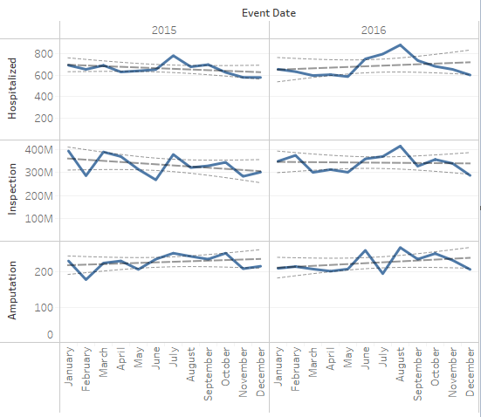

**Injury Incident Heat Map by Industry NACIS**

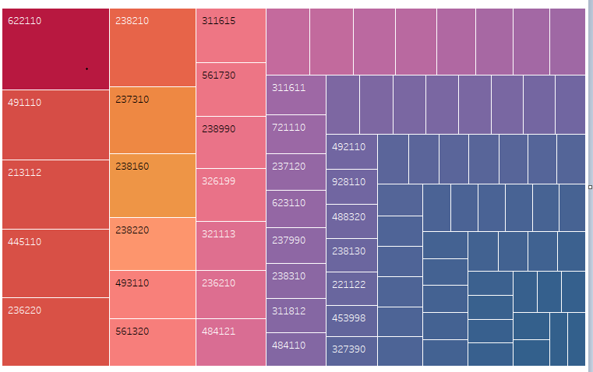

Plotted the injury incident across the months for 2 years and observed that during summer months the injury incident across three different category. In 2015, month of July based on data observed a sharp rise in incident. Again, on 2016 in month of August observed the rise in incident on month of August. Few Industry has higher rate of incident than others in the heat map plotted the incident versus the industry NACIS. We will create a KNN or SVM ranking system to determine the safety ranking for the industry.

**Conclusion:-** Injury incident increase during hot summer months, based on incident categorization across industry we can create a classification model.